Abstract Number: 008-0656
Abstract Title: Service Business Models for Tissue Engineering Products and Therapies

Ari P.J. Vepsäläinen, Ph.D., professor, Helsinki School of Economics Department of Business Technology, Logistics, PO Box 1210, 00100 Helsinki; Katrina M. Nordström, P.h.D., professor and Marko O. Närhi, M.Sc. (Technol.) Helsinki University of Technology, Laboratory of Biochemistry and Microbiology, P.O. BOX 6100, FIN-02015-TKK, Finland.

POMS 19th Annual Conference
LaJolla, California, USA
May 9 to May 12, 2008

INTRODUCTION
Progress in the understanding the differentiation of cells, the regeneration of tissues, methods for expansion and manipulation of cells in vitro, and advances in biocompatible materials have raised hopes for restoring cellular or organ functions that have been lost due to injuries or chronic diseases (Langer & Vacanti, 1999; Lysaght & Reyes 2001; Hardingham, 2003). Tissue engineering (TE) may alleviate organ shortage for transplantation, change treatments for many illnesses, improve the quality of life of patients and perhaps even enable clinical “spare part”- services (Garr, 2001; Williams & Sebastine, 2006). However, before such ambitious goals evolve into reality, many biological, legal, technical, commercial and logistical obstacles must be solved. Not only are patients involved, but cells, tissues and living agents, known and unknown, maintain and transform living nature in often risky ways. The sourcing and matching of tissues for patients is ingrained in the fabric of society through funding of medical and research institutions, regulation, political influence and public interest that greatly impact on the quality standards imposed on TE services and in the long run determine the role of TE as a tool in clinical practice and health care.

Future therapies will most likely involve the use of cells from autologous or allogeneic sources, ie. derived from the same individual or another donor respectively. Populations of cells are cultured, harvested and possibly combined with scaffolds (Griffith, 2002). Cells may collected from a patient, sent to be propagated into desired tissues at either hospital based laboratories, or other outside service providers, and delivered back to the patient by implantation at the hospital (Williams, 2005). Allogeneic cells may be supplied by private, non-profit or hospital cell banks. However, use of living cells is associated with biological risk. Non-preserved products with short life time may be implanted at risk as sterility testing requiring days to weeks for confirmation can not be performed for products to be used in acute patients. Data on other biological and biochemical characteristics may similarly not be available at implantation due to time constrains of testing (Naughton, 2002). Infection can occur at any of the different stages of the supply chain as endogenous (from donor) or as exogenous contamination. Such service risks are mainly caused by a failure at some point of the service process (e.g. mishandling of products, lack of testing etc.). Moreover, even rapid testing methods may not give a final solution, as many of the elements to be tested for such as endogenous prions and viruses are as yet unknown. Accordingly the regulation of TE products by the FDA and the EU employs a strict risk based tiered approach (Anon., 2005; Trommelmans, Selling & Dierickx, 2007).

THEORETICAL PERSPECTIVE
There are only few major profitable products on the market in spite of their demonstrated clinical value. In 1995 sales for TE products were forecasted at $ 2 - $ 3 billion by 2002, but in 2004 sales were estimated at only $ 50 million (Lysaght & Hazelhurst, 2004). Infuse®, approved in 2004 for spinal fusion, is an exception with robust sales and profitability (Hünziker et al., 2006). TE wound care materials are also on the market (Naughton, 2002). However, road maps for TE have primarily focused on biological, engineering, regulatory and business issues from the point of view of the product developer. Production automation, biological complexity of products, and moving from break-even to profit have been recognized as critical challenges (Lysaght & Reyes 2001; Faulkner et al., 2003; Hünziker et al., 2006; Mason & Hoare, 2007). However, service systems for the functioning of the TE supply chain for different products (cells, tissues, organs) from the developer to the hospital, to the transplanting surgeon and ultimately for the maintenance of the quality of life of the patients have not been addressed. Service science engineering and management is one of the fastest growing sectors of global economies, with medicine displaying the highest growth rates (Chase & Apte, 2006).

From science and technology to logistics and services
Clearly, several unique issues must be solved as TE products may need to be manufactured on demand, where also the logistics and services for these novel products present an important cost factor. Furthermore, the distribution and storage of a large collection of heterogeneous TE products need to be coordinated with the specific needs (e.g. surgery schedules) of the users. A need for TE products could be linked to emergencies such as traffic accidents, burns or heart failure. Thus short lead time in production, timely delivery and customized service are imperative. In other cases the need may not be as urgent, but logistics will be of vital importance as some products are constructed from the cells of the patient and the batch size in production is one. Novel customer support and customer assistance services must also be developed to address the needs of the patient. TE products are complex and unfamiliar also to many physicians and surgeons as well. Most importantly, TE products consist of living materials, the customer is strongly involved in the process, and the product and service has significant impact on human life and health.

Earlier research has recognized the importance of logistics in tissue engineering, but little has been published. To date, the majority of logistics and supply chain theories have been developed for manufacturing companies (e.g. automobile manufacturing) or traditional service industries (e.g. banking) where effectiveness, efficiency, minimizing of inventories and costs as well as maximizing of profits are essential. Although efficiency and cost minimizing are important issues also in healthcare, the application of many logistics practices and theories for TE would disagree with public opinion and ethics. Clearly, emerging TE technologies require very specialized services, which must be performed on schedule by skilled labor with significant impact on the total costs of the treatment. Production capabilities and supporting services must also be available for preventing and controlling biological hazards such as changes in cell karyotype, microbial contamination and loss of cell viability during the processing and distribution of these viable spare parts (Nieminen & Kurki, 2004; Heinonen, Oila & Nordstrom, 2005; Mason & Hoare, 2007). Stockholding services, transportation, medical counseling, services during the long follow-up period, are examples of the many other services, which become an essential part of the product. A Tissue engineered heart has no value to the patient without a surgeon offering transplantation service and someone transporting the organ to the hospital. Vice versa, these services can not be performed without the actual physical product, the TE-heart.

Consequently, a prerequisite for establishing a functional platform for TE products as part of future therapies is the development of strategies for efficient supply chain management and versatile services spanning from product development to a follow-up period of possibly decades. Thus, the design and analysis of the supply chain as a whole is critical for achieving efficient supply chain management (Wang, Huang & Dismukes, 2004). Accordingly, the present study aims at identification of the structures of the supply chain of TE products and the future needs for logistics and services for these supply chains as such issues will become imperatives within health care organizations at the international level.

METHODS
The approach of the present study builds on insights gained by studies in operational disciplines and coordination systems for different types of supply chains and service networks combined with research on regulation, biological risk and TE. Service systems are becoming an increasingly important driver of global economies (Chase & Apte, 2007; Karmarkar & Apte, 2007), where services may be best described as applications of specialized competencies (knowledge and skills) through deeds, processes, and performances for the benefit of another entity or the entity itself (Vargo & Lusch, 2004). Consequently, we aim to provide a deeper insight into the research problem of logistics and services of TE by an explorative analysis of examples of selected TE products, namely skin, cartilage and kidney. These have been chosen to demonstrate the biological and functional diversity, complexity and the different supply chain and service requirements. It will be assumed that products are autologous or allogeneic. This study will take no stance on other cell origins, ethics, nor on bioprocessing, which has been explored well by others (Mason & Hoare, 2007).

First, we will identify the actors in the supply chain of TE skin, cartilage and kidney. Identifying the actors in the supply chain is a prerequisite for the subsequent identification of the necessary services. In some supply chains these issues are self-evident, but in the TE chain the customer (e.g. doctor making the treatment decision or the end user) and the focal company are difficult to explicitly identify due to the still infant nature of the TE supply chain. The supply chain is likely to be complicated, but it should be transparent and managed safely and effectively.

Second, we examine the structure of the supply chain in context of lean and agile, e.g. responsive production as well as identifying the supply chain or supply loop as triggered by supply or demand (Hull, 2005). For TE businesses providing eg. cells, tissues and perhaps even organs a lean supply chain can provide higher manufacturing efficiency when demand is stable and can be accurately forecasted. Thus it is suitable for functional products at all stages of product life cycle and also for some innovative products at maturity and decline stages. An agile supply chain focuses on responding to unpredictable market changes. It attempts to achieve speedier delivery and lead time flexibility. The agile supply chain deploys new technologies and methods and enhances production based on customer (eg. hospital) designed orders. The agile supply chain is suited for innovative products at introduction and growth stages (Wang, Huang & Dismukes, 2004).

Third, to study the necessary evolution of the technologies and the service institutions and providers involved, we will introduce a framework for product and service development. Here we classify TE products and services as experimental, therapy and standard products, where for each stage certain services also become evident. Although there are numerous classifications for both services and products, very few classifications succeed in combining these two. Previously products and services have been presented in a continuum, where at one end are the pure products (high in tangible elements) and at the other end pure services (high in intangible elements), (Lovelock, 2000). However, such classification is rather simple and does not offer solutions to the TE supply chain or to managerial decisions at the level of the producer of the service provider thereof. When two different, but in many ways similar services with very different products are considered, the need for combining classification (Tinnilä & Vepsäläinen, 1995) becomes evident: A hairdresser provides customized professional service, but the products (e.g. hair dye) are simple, easy to store even for long periods of time and the availability of the products is secure. A surgeon implanting a TE product to a patient is also performing a professional customized service, but the product is very demanding as it may be customized, have a short shelf life and may be very difficult to procure.

Finally, regardless of how miraculous the actual product is, it has no value to the patients without long-term services. Therefore we also identify services associated with the supply chain for each of the example products. The spectrum of services is wide, but in this first exploratory study we have chosen to focus on regulatory services, information services, ordering services, production and distribution services, promotion and financing services.

FINDINGS
Actors in the supply chain
Five main actors can be identified for the TE supply chain, namely raw material sources, raw material suppliers, logistics process integrators, medical care providers, and end-users (Figure 1). The roles of these actors will affect on the efficiency, traceability, total cost of the product, and the safety, well being and quality of life of the patient over years or decades to come The supply chain is strongly influenced by five other ancillary actors, namely, the regulatory authorities, manufacturing and logistics service companies, information system providers, financiers and insurance companies. These actors must be present for the supply chain to function. The authorities have the greatest influence on the supply chain. The role of logistics companies is also pivotal, especially in centralized delivery where the distances may be long but deliveries must be on schedule. Information systems and data management must be available for providing information safely to all entities and decisions must be made early as to where, how and by whom all relevant data will be securely stored in compliance with the long term traceability demands. Financiers choose the companies and supply chains they support and insurance companies influence the success and profitability via reimbursement of TE treatments and products. These actors may also have multiple roles, e.g. financiers as a group represent both private and public funding, and insurance companies also influence the outcome of the supply chain via possible personal savings invested in insurance. The role of insurance providers is similarly interlinked with national healthcare policies and reimbursement issues. However, structural differences in the health care providers between the EU and the USA are beyond the scope of this paper, as the EU alone encompasses 27 different healthcare systems.

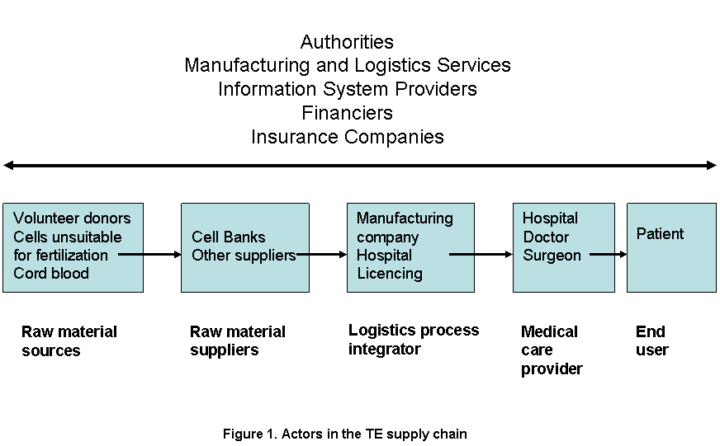

Supply chains of TE skin, cartilage and kidney
The supply chain for TE skin can be described as efficient or lean in the beginning and agile or responsive at the end (Figure 2a). Cells and tissues and other necessary materials, which are acquired from the suppliers (cell banks, hospitals etc.) are grown and form the final product (TE skin). This is then stored and shipped according to customer orders (doctors and hospitals), who apply it to the end users (patients). The production of TE skin products could also be described as responsive push production. The product developer is committed to the production schedule before the actual demand is known due to the long lead time. Purchasing, acquisition and processing of raw materials (cells, growth media, enzymes, growth factors etc.) or cell banks must be started long before the actual demand is known. However, lean production does not fit TE skin products if the production time is relatively long and the products are needed also for acute patients. Manufacture to order type of production is not a reasonable option either, as it would just move the inventories forward in the supply chain towards the hospitals and physicians.

Autologous cartilage production would be best described by a closed loop or reverse supply chain, where the end customer is also the source of raw materials and thus an integral part of the production process (Figure 2b). The chain, or rather the loop, functions purely on pull and manufacture to order or design to customer bases (Wang, Huang & Dismukes, 2004; Hull, 2005; Lovelock, 2000). If the need for cartilage products is not acute, short lead time is not critical. If the demand is not constant, short lead times and timely deliveries would require expensive excess capacity. Inventories are likely to be fairly low in the chain as the key raw material is acquired from the end user and no finished goods inventories can exist.

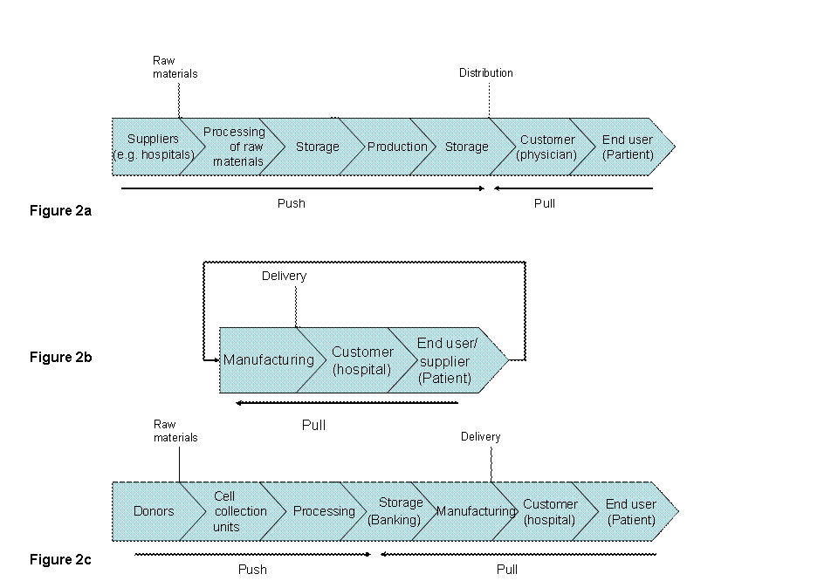

Figure 2. Supply chain for TE-Skin (2a), TE-cartilage (2b) and TE-kidney (2c)

TE kidney is still at the theory stage and no supply chain for these products exists. Consequently, only some speculations on a future supply chain for an allogeneic product are presented. First the cells are processed and stored, second the product is produced from the cells and finally the product is implanted into the patient, which can be considered to represent the third manufacturing phase. The beginning of the chain will be far from lean management (Figure 2c). The cells may be collected years in advance, the time span between the collection of cells and the implantations procedure could be 10 years or even more. Moreover, large inventories may be a necessity if matching cells are needed for a wider group of patients when the end user triggers the production and the final manufacturing will function on pull principle.
Sustaining Life sets strict requirements for logistics
There are numerous classification factors relevant for TE products and their logistics, such as urgency of need (acute or scheduled), nature of demand (variability and amount), complexity of product and service, need for matching, extent of customer involvement, risks to company, customer and to society, supporting service requirements, origin of raw materials, time of cell harvesting (in advance or in need) and duration of the process. Of all classification factors, however, “Life” can be recognized as most important. In TE Life has many dimensions as 1) customers are strongly involved in the process and in some cases also in the production, 2) the product consists of living materials, which adds to the risks as the product is not sterile and may grow or change functionally or structurally after the implantation, and 3) the purpose of the product and service is to affect on human life and health. Moreover, quality is an important factor for all products and services. For medicinal products, quality is defined by certain standards as the product, process and service all have to fulfill strict safety requirements. Safety aspects cover potential or harmful effects of the product, efficacy is the beneficial effect of the product to the patient and quality relates to development, manufacture and distribution. One of the most critical issues are clearly those related to microbial hazards either linked to donors or contamination during processing and implantation. From a logistics point of view transportation presents an additional infection risk especially in centralized multi-echelon distribution, where there can be several stages and modes of transportation. In many products (e.g. low value consumer goods) some amount of damage during distribution and transportation is acceptable. However, for TE products or components, the amount of damaged products or packages in transportation and distribution should be close to zero, as contamination could be life threatening.
The product is the service
The evolution of TE products and services can be classified into three stages, namely experimental, therapy and standard (Figure 3a). At the experimental stage products and services are still in the test tube or research cases only providing ideas or visions of potential products. The experimental stage is labor intensive and the product and service are not separable. At the therapy stage the product or service can be offered to selected e.g. terminal patients, as a unique product, but not as yet directly and widely to all the potential patients. The product is demanding to make and so customized that the product conceptualizes from the application service process. The entire process is performed in a research hospital as a single treatment. Consequently, we argue that eg. TE skin is still at the therapy stage, where the products are special as they are still closely linked with services such as. hospitals. On the other hand, TE skin is becoming more standardized and offers possibilities for becoming less service intensive. Thus, when TE skin can be applied by the patient as a “band-aid” it will have reached the standard stage. On the other hand, to compete as a product amongst others, patient services for follow-up may still be necessary for such “band-aid” applications depending on the extent of the injury to be treated.
The required services for products at different stages will also reflect onto strategy and the management of the supply chain and the logistics (Figure 3 a-b). As products move from being potential products to custom and mass products the importance of logistics changes from a minor role to being a strategic driver. The role of logistics for products at the experimental stage is minor, whereas for products as the therapy stage, logistics becomes an enabler and will determine the availability of the product. Functional transportation and storage methods are prerequisites for moving into the therapy stage. More specifically, the evolution of TE products may be hypothesized by using the development of organ transplantation and blood products as references (Figure 3b). Organ transplants are currently at the therapy stage as is TE skin. The procedures of organ transplantation are standardized, but there are still many risks involved and organ transplants can not be characterized as conventional. The limited availability of organs for transplantation also affects on the development. The “product” and the service are still closely linked as is also TE skin, although TE skin, being a less complicated product with smaller risks, is bordering on the standard stage.

As products evolve into the standard stage, logistics becomes a strategic driver for which blood products present an interesting example (Figure 3b). First studies on blood products in the 17th century exemplify potential products at the experimental stage. Blood “products” may be considered as having developed to the therapy stage with the first animal-to-animal and animal-to-human blood transfusions. Discovery of blood types in 1901 allowed blood services to develop and when preservation, storing and transportation methods as well as regulation of blood products became established, blood banking became possible, separating the product from the service, where the role of logistics was that of an enabler. Today there are many different blood products on the market and blood transfusion is common practice, thus having reached the standard stage, where efficient logistics and services have become a strategic driver (Figure 3 a-b). Interesting analogies to traditional spare parts and repair service are also evident, where the role of logistics as a strategic driver is also well established (Kennedy et al., 2002).
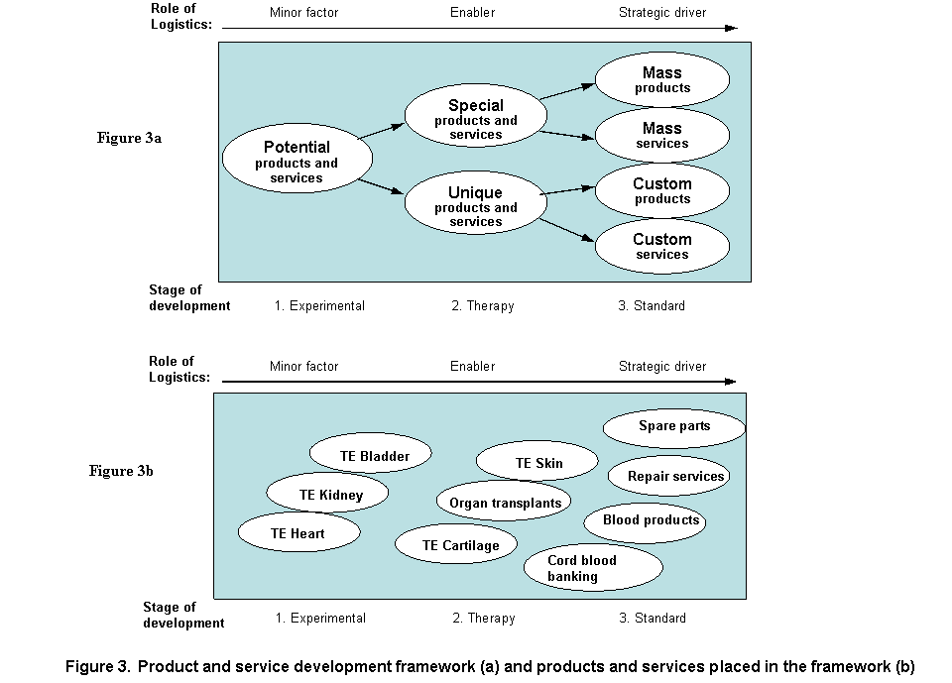
The service requirements for TE will also become more diverse as the products develop further and the role of the actors in the chain may be examined in context of the provision and nature of the changing services (Table 1). The services may be viewed as overlapping as the emphasis of the nature of the service may shift, whereas the importance does not diminish.
SERVICE  REQUIREMENTS | EXPERIMENTAL  Potential product | THERAPY  Unique or Special  product | STANDARD  Custom or Mass product
Regulatory  services | Regulatory professionals, scientific community | Clinical trials, risk management, traceability, bringing to market | Post-marketing surveillance, adverse reactions, follow-up
Information services | Communication between researchers, research reports and case studies | Recording and distributing patient information and treatment results | Coordination between service providers, logistics process integrator and manufacturer
Ordering services | Doctors book interesting/feasible cases into program, patient selection | Doctors and department accept referrals and hospital patients | Doctors enroll patients to programs and individual treatments
Production and distribution services | Clinical services at hospitals and research facilities | Special cell banks and production laboratories used by general hospitals | TE sourcing and distribution provided by manufacturing and service companies
Promotion services | Medical research community referring based on reputation | Hospitals and doctors look for interesting cases | TE services and products advertised as part of hospital and HMO services
Financing services | Research funding, institutional budgets | Institutional funding (eg. research, intensive care), insurance for end-customer | Patient fees and materials paid by end customers and insurance companies

Regulatory services play a pivotal role at each of the stages of development, where the service includes actions of regulatory professionals and authorities. This accommodates services such as regulatory advice and guidelines or services which are ingrained into legal requirements. Accordingly, the role of regulation may be viewed as a service, which must be triggered by the manufacturer, which may also be a hospital. Product complexity will influence the relevance of regulatory activities. As the products evolve, the long term follow-up over decades will be an important driver for the kinds of regulatory activities that must be implemented. Regulatory requirements for post-marketing surveillance including risk management, adverse reactions and services for facilitating patient follow up will play a crucial role with direct implications towards the organization and provision of services by society and healthcare institutions. Other services such as the role of information systems changes from communication between researchers and research data banking including tissue registries (Williams, 2006) to cooperation between service providers and manufacturers to effective data management at the standard stage. Ordering services at the experimental and therapy stages involve e.g. patient selection and referrals, who are allocated into individual treatments at the standard stage. Production and distribution services at the experimental stage are mainly focused on the needs of research establishments and hospitals, such as transport of raw materials and equipment. However, as an enabler, the role of logistics at the therapy stage will be emphasized by needs of cell banks and production facilities used by hospitals. Sourcing and distribution provided by manufacturers and service companies are emphasized at the standard stage, where logistics services will become a strategic choice. Promotion services will also play a significant role as reputation of medical facilities, selecting most suitable patients and finally, the advertising of TE services and products will influence on the ultimate outcome of these therapies. Financial service requirements are imperative at all stages, but the role of these services evolves towards the customers and end-users and services such as patient insurance, as products mature from experimental to standard.

IMPLICATIONS

The biological characteristics of TE products determine the type of supply chain and the roles of each of the actors within the chain, as the products represent a wide and heterogeneous group, ranging from cells to implantable organs with or without scaffolds. The present study has examined only a few selected supply chains as examples but it is also useful to consider the mechanisms of TE products also as facilitating repair, inducing repair and replacement (Hünziker et al., 2006). The more difficult the functional task, the more technologically challenging the product development. In light of the present study it is also evident that the more technologically challenging the product, the more extensive is the need for logistics and the greater the impact of health services are, extending from the beginning to the end of the TE supply chain. Moreover, requirements for accompanying services are dependent on the complexity of products as they emerge from being potential products to mass and custom products. Although many conventional products are also closely linked to services, the classification described in the present paper is more accommodating for TE as it connects the product and service dimensions and offers managerial suggestions accordingly (Tinnilä & Vepsäläinen, 1995). A central issue for the commercial success of TE products and therapies is therefore the question of what types of services are necessary to support the commercialization of mass products or should the focus be on special services needed for custom products ?

Although many service risks are connected to the biology of TE products, it has also been argued that TE is associated with less risk than conventional medical devices or medicinal products. Medicinal products are mass produced and the hazards related to defective products or unforeseen mechanisms can affect thousands of patients (Wassenaar, Geerstam & Kallewaard 2001). On the other hand, TE is currently a customized process that is directed towards individual patients, which minimizes the scale of the hazard. However, as TE becomes more common and more commercial products emerge onto the market, the risks may also grow.

Estimations for potential markets for TE products are still difficult to make, as this will depend also on the extent to which patients will be treated with TE options (Bock, Ibarreta & Rodriguez-Cerezo, 2003). Other treatment options do exist, which may be less expensive. Furthermore, not enough experience has been gained on the differences in efficacy of TE in comparison to conventional treatments. Clearly, business models for TE will not be akin to standard medical devices or drugs, where products are delivered as off-the-shelf, nor is it likely that single therapy autologous products could become profitable (Williams, 2005). Ultimately, therefore the clinical success of TE will be determined by the total cost to governments, insurance companies and individual patients, where the safe and reliable performance of the product is closely tied to the types of services available. These implicate the role of services as an important factor in the design and management of the supply chain of individual products, which must meet demands for traceability and patient follow-up over future decades. In conclusion, the success of TE in clinical care in the long run will be determined by how society evaluates the price tag for safety and efficacy, cumulating in provision of sustainable logistics and versatile service institutions for the maintenance and quality of life.

REFERENCES
Anon. (2005). “Code of Federal Regulations. Food and Drugs, revised April 1, 2005. Chapter 1, Part 1270 Human Tissue Intended for Transplantation. Part 1271 Human Cells, Tissues and Cellular and Tissue Based Products.” Food and Drug Administration, HHS, 21 CFR Ch. I (4-1-05 Edition).
Chase B. & Apte, U.M. (2007). “A history of research in service operations: What’s the big idea ?” Journal of Operations Management, 25, 375-386.
Faulkner, A., Geesink, I., Kent J.& FitzPatrick, D. (2003). “Human tissue engineered products – drugs or devices ? Tackling the regulatory vacuum.” British Medical Journal, 326, 1159-1160.
Garr, D. (2001). “ The Human Body Shop.” Technology Review, 104, 72 – 75.
Griffith L.G. (2002). “Emerging design principles in biomaterials and scaffolds for tissue engineering.” Tissue Engineering: Chondrocytes and Cartilage, 961, 83-95
Hardingham, T. (2003). “Regional perspectives on tissue engineering – View from a small island.” Tissue Engineering, 9, 1063-1064
Heinonen, M., Oila, O.& Nordström, K. (2005). ”Current issues in the regulation of human tissue-engineering products in the European Union.” Tissue Engineering, 11, 1905- 1908.
Hull, B. Z. (2005). “Are supply (driven) chains forgotten? ” The International Journal of Logistics Management, 16, 218 – 236.
Hünziker, E., Spector, M., Libera, J., Gertzman, A., Savio, L.-Y.W., Ratcliffe, A., Lysaght, M., Coury, A., Kaplan, D. & Vunjak-Nivakovic, G. (2006). “Translation for Research to Applications”. Tissue Engineering, 12, 3341- 3360
Langer, R. & Vacanti, J.P. (1999). “Tissue engineering: the challenges ahead.” Scientific American, 280, 86-89.
Lovelock C. (2000). Services Marketing: People, Technology, Strategy. Upper Saddle River, NJ : Prentice Hall.
Lysaght, M.J. & Hazelhurst, A.L. (2004). “Tissue Engineering: The End of the Beginning.” Tissue Engineering, 10, 309 - 320 .
Karmarkar, U.S. & Apte, U.M. (2007). “Operations management in the information economy: Information products, processes, and chains.” Journal of Operations Management, 25, 438 – 453.
Kennedy W.J., Patterson, J., Wayne, J. & Fredendall Lawrence, D. (2002). “An overview of recent literature on spare parts inventories.” International Journal of Production Economics, 76, 201-215.
Lysaght, M.J. & Reyes, J. (2001). “The Growth of Tissue Engineering”. Tissue Engineerign 7, 485- 493.
Mason, C. & Hoare, M. (2007). “Regenerative medicine bioprocessing: Building a conceptual framework based on early studies.” Tissue Engineering , 13, 301 – 311.
Naughton, G.K. (2002). “From Lab Bench to Market. Critical Issues in Tissue Engineering.” Annals of the New York Academy of Science, 961, 372-385.
Nieminen, O. & Kurki, P. (2004). “Risk Management for Biological Products.” International Journal of Pharmaceutical Medicine, 18, 149-157.
Tinnilä, M. & Vepsäläinen, A.P.J. (1995). “A Model for Strategic Repositioning of Service Processes.” International Journal of Service Industry Management, 6,57- 80.
Trommelmas, L., Delling J. & Dierickx, J. (2007). “A critical assessment of the directive on tissue engineering of the European Union.” Tissue Engineering, 13, 667- 672.
Vargo, L.V. & Lusch, R.F. (2004). “Evolving to a dominant logic for marketing.” Journal of Marketing, 68, 1 – 17.
Wang G., Huang S.H., & Dismukes, J.P. (2004). “Product-driven supply chain selection using integrated multi-criteria decision-making methodology.” International Journal of Production Economics, 91, 1-15.
Wassenaar, C, Geetrsma, R.E., & Kallewaard, M. (2001). Tissue engineered medical products (TEMPs): A prelude to risk management. RVM report 605148009.
Williams, D. (2005). “Business models for biomaterials in regenerative medicine.” Medical Device Technology, June 1, 7-8.
Williams, D. (2006). “A registry for tissue engineering clinical trials.” Medical device Technology, June 1, 9-10.

